Cleveland整体图片 （空地俯瞰）

怎么把段落改成白色的

如何add data到Mapbox

https://storymaps.arcgis.com/stories/943f26c946994574a8d5f05cecf10a59

Zoom in 到我们的case study区域 （小neighborhood）

Cleveland 交通TOD

Cleveland 15-minute 的那个图

In the initial planning phase, experts produce data-driven land use recommendations using GIS through the City initiatives, the council, internal departments within the City, and community development corporations (CDCs). In the meantime, residents receive training on basic planning concepts and technology used for groundtruthing before going for the field test where they groundtruth the recommendations. Finally, stakeholders debrief the recommendations proposed by residents and reconcile any disagreements. The City produces a report of final land uses for investors, enabling them to locate projects that align with the City’s final recommendations.

载入style载入图层

Week 12 storymaps

如何add on多个页面？

如何单独加图而不加map

~~如何旋转但别旋转太多？？~~

如何add on不是同一张图的页面呢？

https://blog.mapbox.com/how-to-build-a-scrollytelling-map-ead6baf2cd1b

不知道怎么加heatmap，它无法显示

我的video错位了。

我还想问个问题。就是我要怎么改图片大小呢。我一直在config里面改，然后我一直没有动过css。

我怎么把我电脑里而不是网页图片加进去？？我的final图片

如何不要让对方消失，而是直接不显示呢

有的图层可以调可见度，15 minute调不了

1. minute city index挡住后面

有什么课程可以学这个

可以一页又加图又加这个视频

有时候会出现15-city index的图层

**第二页没有旋转？虽然我加了旋转代码**

**15 minute index需要刷新才可以看见**

**最后一页改Location但没有反应**

Mapbox里面的图层需要开着还是关上

怎么加Legend

<https://npr.brightspotcdn.com/dims4/default/df2a86c/2147483647/strip/true/crop/4032x2117+0+454/resize/1200x630!/quality/90/?url=http:%2F%2Fnpr-brightspot.s3.amazonaws.com%2F8e%2F54%2F5a9c017a4c6d84c390ce0ac6944c%2Fron-brown.jpg>

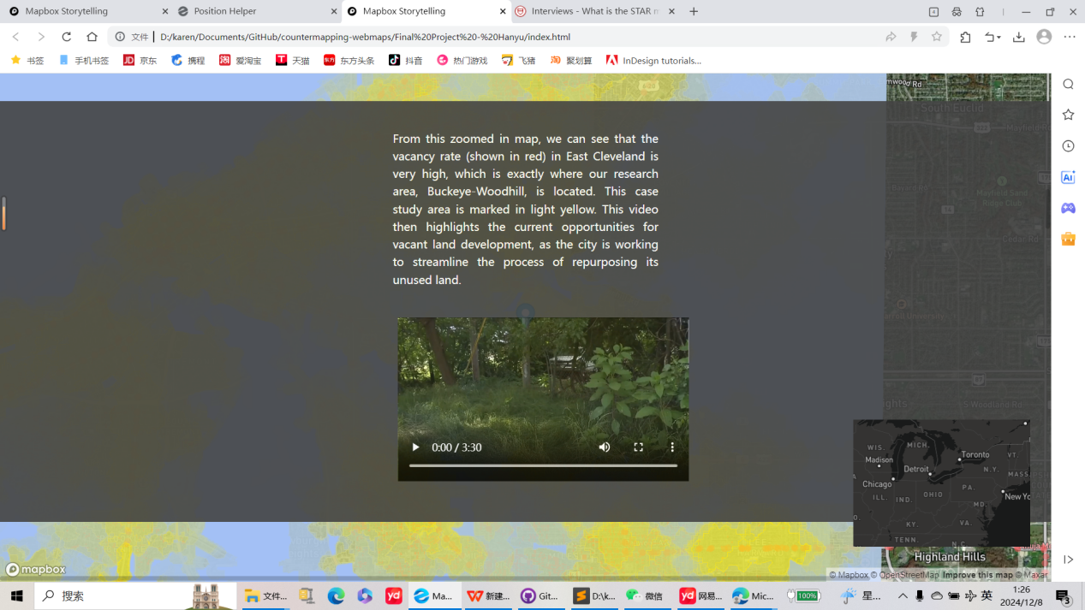

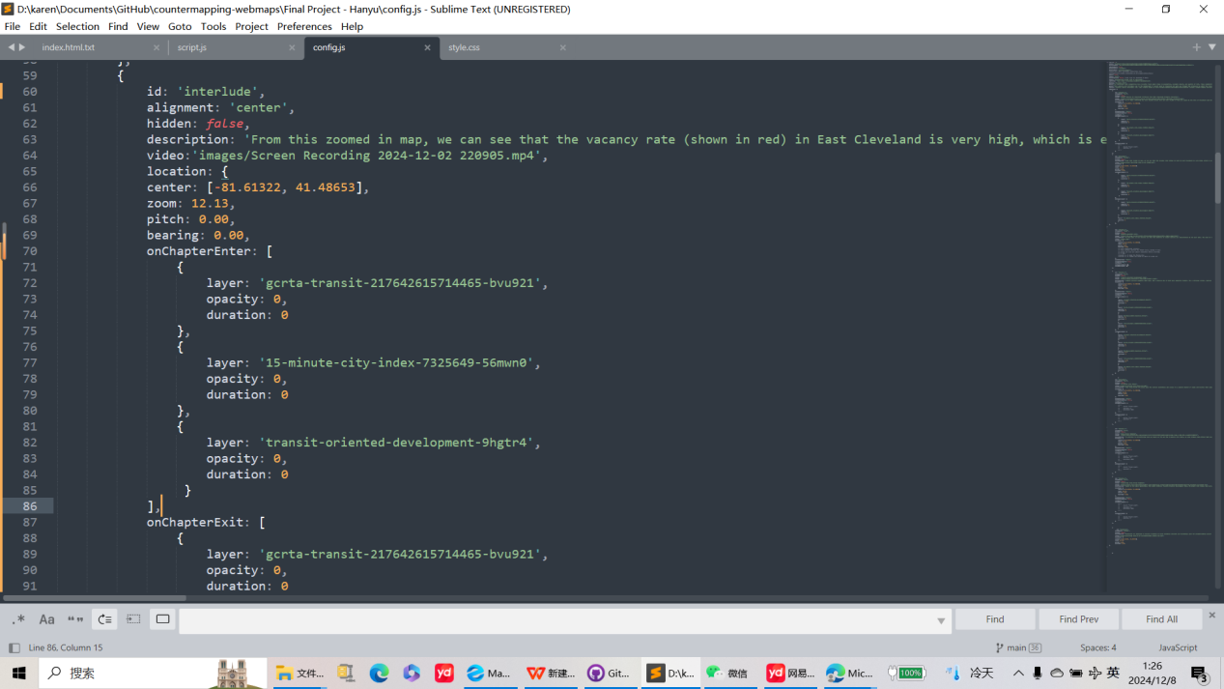

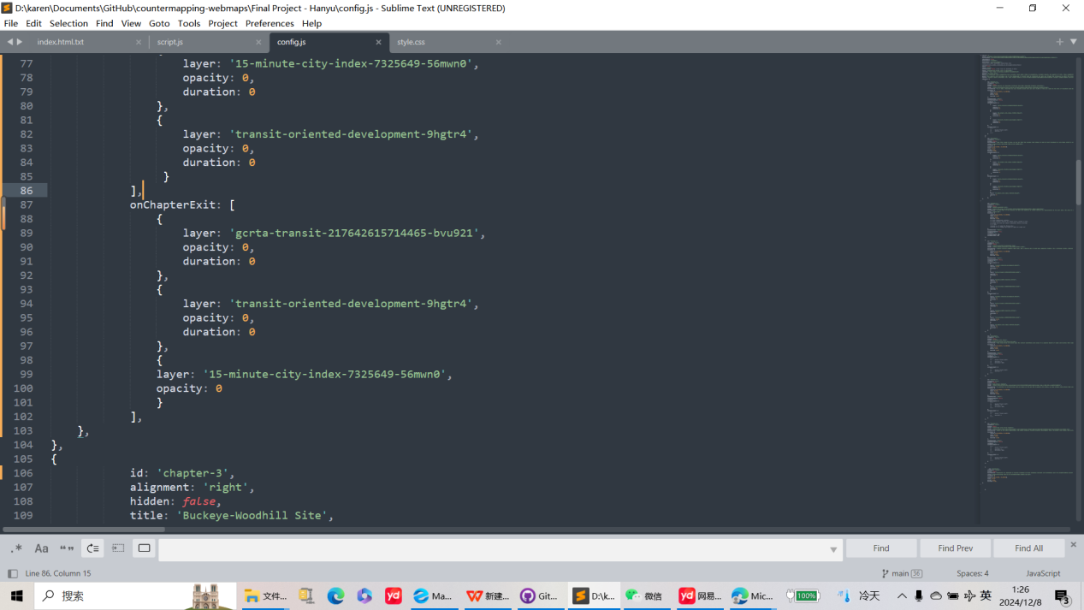

我的final product

Map out the boundary of the neighborhood

The 15 Minute City Index is an important indicator for giving land use recommendations to vacant land parcels. This can be a reference for the city to improve access to necessities and amenities by promoting business openings, housing renovations, and construction projects, as well as enhancing multi-modal transportation.

The 15 Minute City Index (ranked out of 36) results from a weighted sum analysis of walkable areas surrounding points of interest identified by the Cleveland City Planning Department. The various locations are aggregated based on their assigned weights to generate a comprehensive index score. High-scoring areas (30 or higher) indicate greater opportunities for human interaction, while lower-scoring areas (below 25), excluding industrial or transportation corridors, such as rail or highways, demonstrate areas with fewer amenities and services. By prioritizing development in high-scoring areas, the city is demonstrating its preference for compact growth objectives.

Initial Planning Phase (1 Month)

· Planning experts produce data-driven land use recommendations using GIS through insights from the City, the council, internal departments within the City, and community development coorporations (CDCs).

· Residents receive training on basic planning concepts and technology used for groundtruthing vacant parcels.

· Groundtruthing: residents survey each parcel in person to see whether their firsthand experience matches the preliminary land use recommendations.

Groundtruthing Phase (1 Month)

· Residents groundtruth the data-driven recommendations. They confirm whether they agree with the preliminary suggestion or recommend a different land use.

Collaborative Mapping

Organizations like Habitat for Humanity Cleveland and Art x Love have done mapping in this neighborhood and have already selected certain areas and vacant lots for future projects that should be reflected on future land use maps.

Groundtruthing Vacant Lots

By groundtruthing the data, some of these questions could be answered. Groundtruthing is using field work to enhance any mapped or data-based information by observing any real-life conditions or circumstances.

Data, mapping and scoring provides valuable information about each vacant parcel, yet the realities of the land and its environment are also significant factors for potential development.

50line 开始

id: 'interlude',

alignment: 'center',

hidden: false,

description: 'From this zoomed in map, we can see that the vacancy rate (shown in red) in East Cleveland is very high, which is exactly where our research area, Buckeye-Woodhill, is located. This case study area is marked in light yellow. This video then highlights the current opportunities for vacant land development, as the city is working to streamline the process of repurposing its unused land.',

video:'images/Screen Recording 2024-12-02 220905.mp4',

location: {

center: [-81.61322, 41.48653],

zoom: 12.13,

pitch: 0.00,

bearing: 0.00,

},

},

{

id: 'second-identifier',

alignment: 'right',

hidden: false,

title: 'Buckeye-Woodhill Site',

image: 'https://th.bing.com/th/id/OIP.t5TzDAuIiKg1YVObCqOUGwHaFj?rs=1&pid=ImgDetMain',

description: 'In this map, we can clearly see that the majority of vacant parcels are concentrated in the east side.',

video: 'Video1.mp4',

location: {

center: [-81.60068, 41.49103],

zoom: 14.93,

pitch: 0.00,

bearing: 0.00,

// flyTo additional controls-

// These options control the flight curve, making it move

// slowly and zoom out almost completely before starting

// to pan.

//speed: 2, // make the flying slow

//curve: 1, // change the speed at which it zooms out

},

mapAnimation: 'flyTo',

rotateAnimation: true,

callback: '',

onChapterEnter: [],

onChapterExit: []

},]

}